-- Habilitar la extensión PostGIS

--CREATE EXTENSION IF NOT EXISTS postgis;

-- Crear la tabla farmacias

CREATE TABLE farmacias (

id SERIAL PRIMARY KEY,

nombre VARCHAR(100),

latitud DOUBLE PRECISION,

ubicacion GEOMETRY(POINT, 4326)

);

INSERT INTO farmacias (nombre, latitud, ubicacion)

VALUES (

'Farmacia Similares 1',

19.451054, -99.125519,

ST_SetSRID(ST_MakePoint( 19.425738039059762, -99.13331598045133 ), 4326)

); SELECT * FROM public.farmacias

ORDER BY id ASC LIMIT 100

INSERT INTO farmacias (nombre, latitud, ubicacion)

VALUES (

'Farmacia Similares 2',

19.451054,

ST_SetSRID(ST_MakePoint(

19.424442919762303, -99.1259345412545 ), 4326)

);

INSERT INTO farmacias (nombre, latitud, ubicacion)

VALUES (

'Farmacia Similares 3',

19.451054,

ST_SetSRID(ST_MakePoint( 19.425778511371462, -99.13348764182801), 4326)

);

INSERT INTO farmacias (id,nombre, latitud, ubicacion)

VALUES (

1, 'Farmacia Similares 4',

19.451054,

ST_SetSRID(ST_MakePoint( 19.43787928038406, -99.1237029433459), 4326)

);

INSERT INTO farmacias (id,nombre, latitud, ubicacion)

VALUES (

3, 'Farmacia Similares 4',

19.451054,

ST_SetSRID(ST_MakePoint(19.429744749153798, -99.10379022361451), 4326)

);

INSERT INTO farmacias (id,nombre, latitud, ubicacion)

VALUES (

5, 'Farmacia Similares 6',

19.451054,

ST_SetSRID(ST_MakePoint(19.406562992648414, -99.15483172401436), 4326)

);

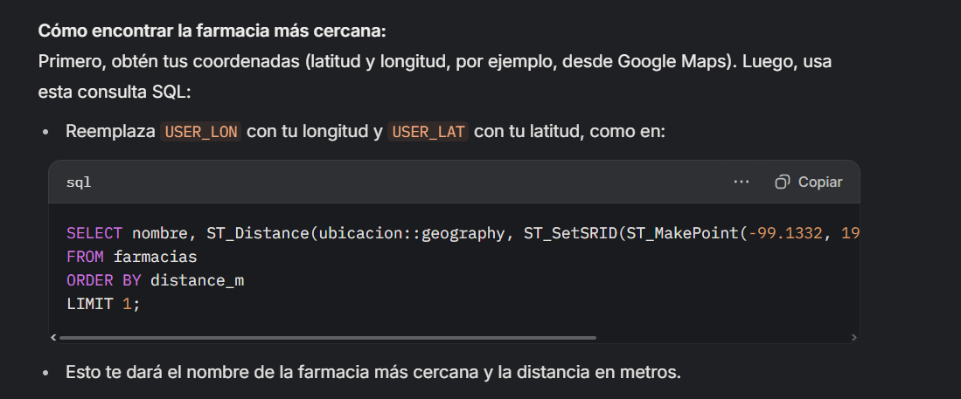

SELECT nombre, ST_Distance(ubicacion::geography, ST_SetSRID(ST_MakePoint(19.430391543573673, -99.12171927656048), 4326)::geography) AS distance_m

FROM farmacias

ORDER BY distance_m

LIMIT 1;

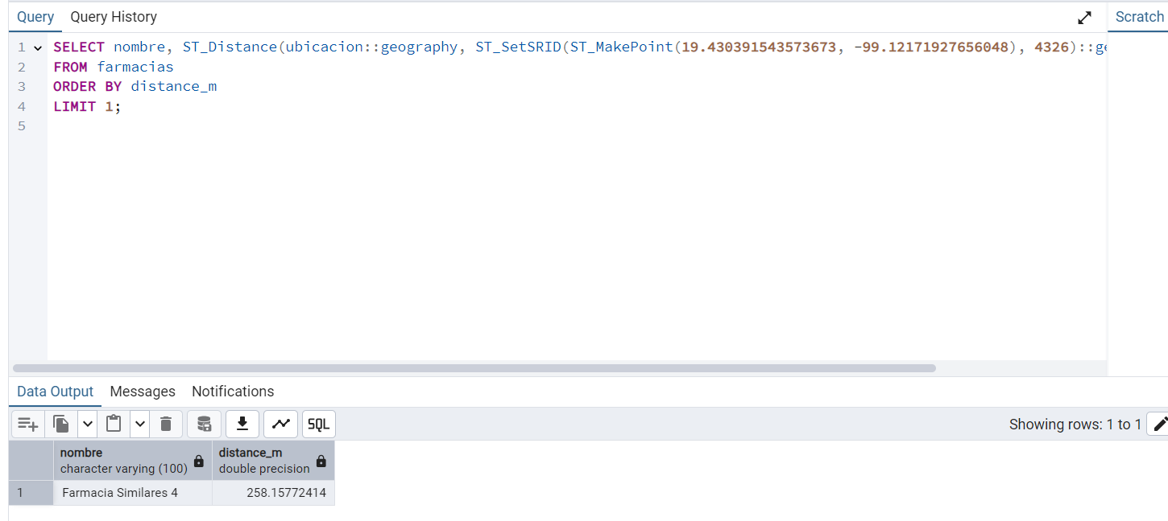

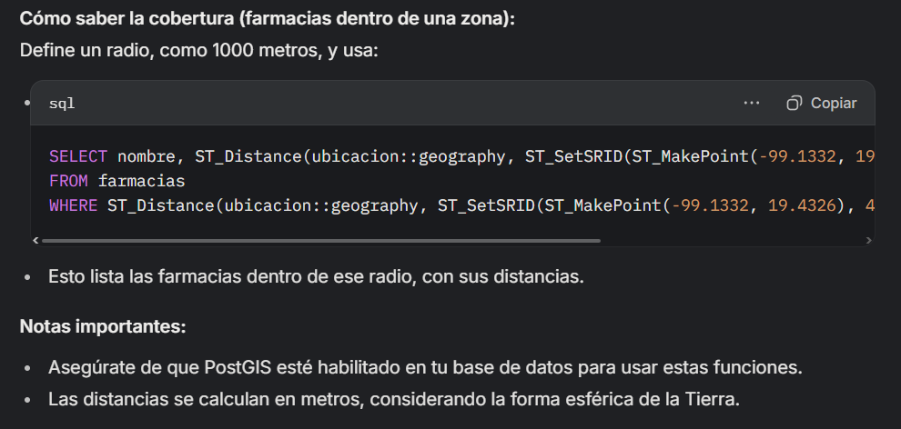

SELECT nombre, ST_Distance(ubicacion::geography, ST_SetSRID(ST_MakePoint(19.430391543573673, -99.12171927656048), 4326)::geography) AS distance_m

FROM farmacias

WHERE ST_Distance(ubicacion::geography, ST_SetSRID(ST_MakePoint(19.430391543573673, -99.12171927656048),4326)::geography) < 1000;

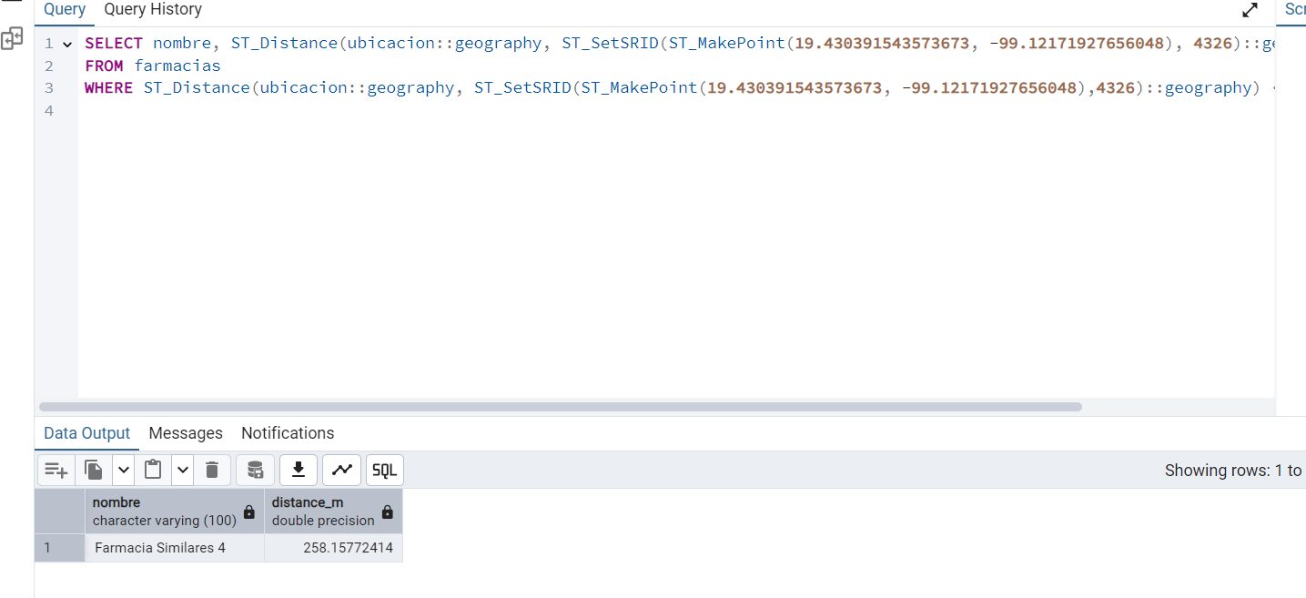

Eliminar

DELETE FROM farmacias

WHERE id = 1;

SELECT * FROM public.farmacias

ORDER BY id ASC LIMIT 100

-- Verificar los datos

SELECT id, nombre, latitud, ST_AsText(ubicacion) AS ubicacion

FROM farmacias;